Lesotho

## Respect for rule of law (ROL) data

The data set shows the data on the respect of the rule of law for the country.

## # A tibble: 19 x 5  
## country iso3c date ruleOfLaw ruleOfLawCategory4   
## <chr> <chr> <dbl> <dbl> <chr>   
## 1 Lesotho LSO 1996 0.0984 ROL moderately respected   
## 2 Lesotho LSO 1998 0.196 ROL moderately respected   
## 3 Lesotho LSO 2000 0.142 ROL moderately respected   
## 4 Lesotho LSO 2002 0.0881 ROL moderately respected   
## 5 Lesotho LSO 2003 0.0924 ROL moderately respected   
## 6 Lesotho LSO 2004 -0.107 ROL moderately disrespected  
## 7 Lesotho LSO 2005 -0.121 ROL moderately disrespected  
## 8 Lesotho LSO 2006 -0.223 ROL moderately disrespected  
## 9 Lesotho LSO 2007 -0.295 ROL moderately disrespected  
## 10 Lesotho LSO 2008 -0.231 ROL moderately disrespected  
## 11 Lesotho LSO 2009 -0.212 ROL moderately disrespected  
## 12 Lesotho LSO 2010 -0.277 ROL moderately disrespected  
## 13 Lesotho LSO 2011 -0.252 ROL moderately disrespected  
## 14 Lesotho LSO 2012 -0.245 ROL moderately disrespected  
## 15 Lesotho LSO 2013 -0.202 ROL moderately disrespected  
## 16 Lesotho LSO 2014 -0.210 ROL moderately disrespected  
## 17 Lesotho LSO 2015 -0.174 ROL moderately disrespected  
## 18 Lesotho LSO 2016 -0.168 ROL moderately disrespected  
## 19 Lesotho LSO 2017 -0.275 ROL moderately disrespected

## Respect for rule of law (ROL) trend

The plot shows the trend of the respect for the rule of law for the country.

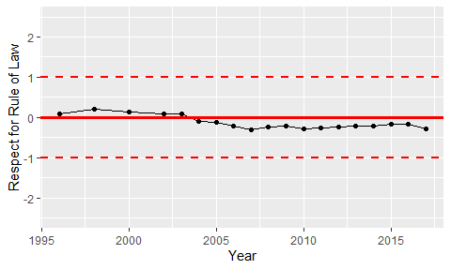

Trend of the Respect for the Rule of Law